Trinity Selective Licensing Area
Zone 1 (Grange st Area) Audit
Target Area
Officers from the Housing department's selective licensing team audited Zone 1 (Grange Street area) between November 2025 and March 2026. This zone comprises Grange Street, Pritchard Street, Herbert Street, Baker Street, Sefton Terrace, and Willis Street, alongside 1–19 Every Street, 32–79 Piccadilly Road, 2–60 Raglan Road, 43–123 Albion Street, and 1–33 St Matthew Street.

Remit
The audit evaluated local property conditions, safety compliance, and occupancy accuracy through a combination of field inspections and internal data reviews. Fieldwork focused on identifying backstreet fly-tipping, assessing backyard security and waste bins, spotting property defects, and confirming vacant property statuses. Officers also verified landlord details, matched occupancy data against Council Tax records, and where accessible checked for smoke alarms and gathered tenant feedback. Finally, an internal review was conducted to ensure valid compliance certification for GSCs, EICRs, and EPCs.

Neighbourhood
The area is a traditional, densely built terrace area. It is primarily characterized by affordable housing, convenient access to the town centre, and close proximity to Scott Park.

The properties are Predominantly two-bedroom, traditional brick terraced houses with rear yards. It is a budget-friendly area. Recent historical sold prices typically range between £50,000 to £75,000, making it popular for buy-to-let investors and first-time buyers.

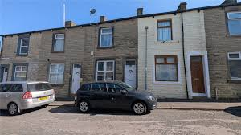

Residents have walkable access to Burnley Town Centre and its local shops, supermarkets, pubs, and restaurants. It is highly convenient for commuters, featuring quick walking access to both Burnley Manchester Road, Burnley Barracks train stations, as well as immediate driving access to the M65 motorway.

Scott Park is located nearby, providing a large, open green space for walking, sports, and leisure.

There are 334 properties in Zone 1. 229 properties are classed as Part 3 (Housing Act 2004) and therefore require a licence. 83 were identified as not having a licence. Of the 105 that are not required to be licensed, 16 are currently vacant, whilst the others are either owner occupied, belong to a Registered Social Landlord , Commercial or Exempt due to either having a family living at the property or there is a long lease in place.

Dirty Backyards and Wheelie Bins
11 properties were identified as having a dirty backyard. These properties were brought to the attention of the landlords and managing agents and in the main the backyards have been cleared. There were no properties identified as not having a wheelie bin.

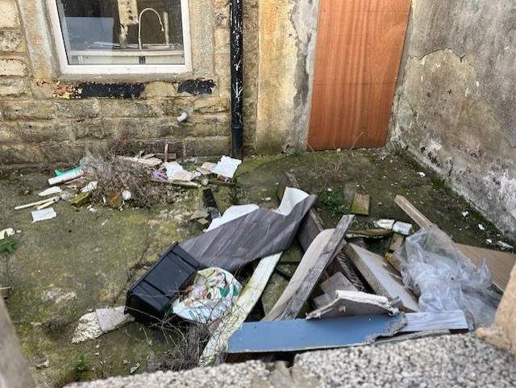

It is a condition of the landlord’s license that they provide waste disposal equipment at the start of the tenancy. Where no evidence can be provided by the landlord that they have issued waste disposal equipment, the Council can take action against the landlord for a breach of the conditions of their licence and can result in a Civil Penalty.

Properties having wheelie bins reduce the likelihood of a dirty backyard and fly tipping in the area.

Back streets and Fly-tipping
During the audit period, fly-tipping was identified at several locations, including the rear of Piccadilly Road, Albion Street, and Baker Street. While the perpetrators remain unidentified, the council has successfully cleared all waste from these sites.

Selective Licensing and Streetscene will continue to monitor these streets and the wider area with a view to taking action against the perpetrators.

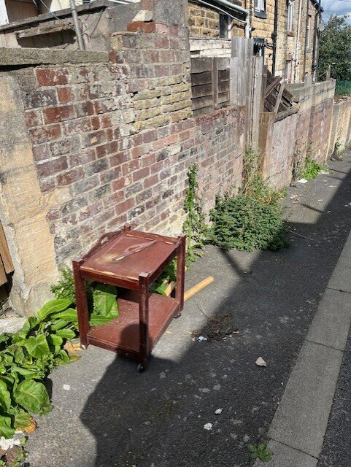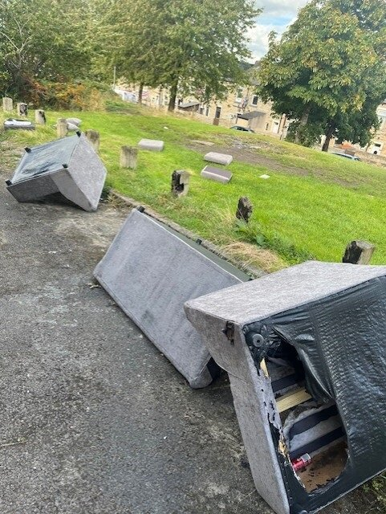

Smoke Detection
There was no smoke detection breaches identified.

Gas Safety Certificate
Six properties were identified as having an expired Gas Safety Certificate (GSC). Following contact with the landlords, valid GSCs have now been submitted. Landlords who fail to supply a valid certificate by the due date breach their licence conditions and may face a civil penalty.

Energy Performance Certificate (EPC)
All the rented properties met the minimum acceptable EPC rating of ‘E’ or above.

Electrical Installation Condition Report (EICR)
No expired EICR were identified.

Property Disrepairs
During the audit, the team identified 66 properties requiring landlord maintenance. Primary issues included broken gates, perished pointing, damaged yard walls, leaking gutters, and deteriorated paintwork. Schedules of work were promptly issued to the respective owners and managing agents. Due to adverse winter weather, several landlords requested and received deadline extensions until Spring/Easter to ensure optimal repair conditions. To date, 32 of the identified defects have been successfully resolved. The remainder will continue to be monitored.

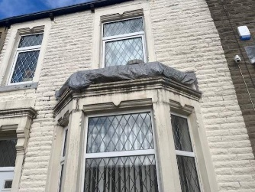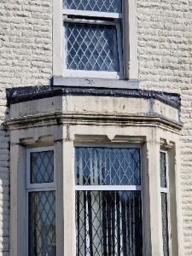

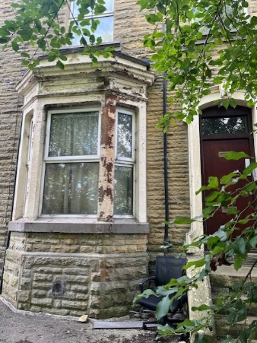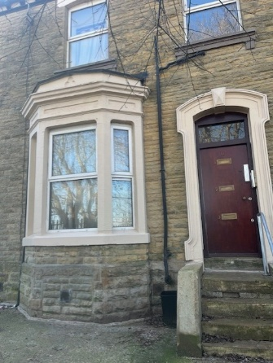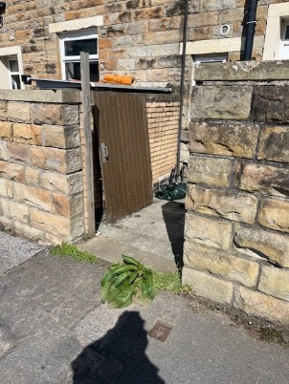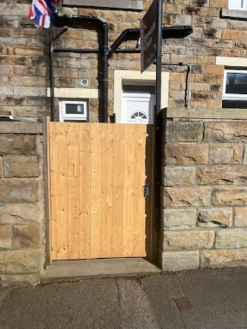
Anti-Social Behaviour
No major ASB cases relating to private rented properties were picked up on audit day.
Follow UP
The area will continue to be monitored by both Housing and Streetscene Officers throughout the remainder of the Selective Licensing Designation.
Summary (Zone 1) Grange Street Area November 2025

 | Albion Street | Baker Street | Every Street | Grange Street | Herbert Street | Piccadilly Road | Pritchard Street | Queensberry Road | Raglan Road | Sefton Avenue | Sefton Terrace | St Matthew Street | Willis Street
Total Properties | 40 | 13 | 9 | 53 | 55 | 35 | 50 | 5 | 30 | 2 | 15 | 15 | 12 | 334
Part 3 | 16 | 12 | 6 | 45 | 41 | 29 | 37 | 3 | 17 | 0 | 9 | 6 | 8 | 229
Licenced | 5 | 2 | 0 | 15 | 17 | 4 | 12 | 2 | 8 | 0 | 4 | 2 | 5 | 76
Applied Not yet Licenced | 6 | 7 | 2 | 11 | 8 | 10 | 8 | 0 | 7 | 0 | 6 | 2 | 3 | 70
Exempt RSL | 3 | 0 | 1 | 1 | 1 | 0 | 2 | 0 | 1 | 1 | 2 | 0 | 1 | 13
Exempt Selective Licence | 0 | 0 | 0 | 0 | 0 | 1 | 0 | 0 | 0 | 0 | 0 | 0 | 0 | 1
Owner Occupied | 16 | 0 | 2 | 6 | 9 | 9 | 9 | 2 | 10 | 1 | 4 | 8 | 2 | 78
Business Premises | 1 | 0 | 0 | 0 | 0 | 1 | 0 | 0 | 0 | 0 | 0 | 0 | 0 | 2
Vacant | 3 | 0 | 0 | 1 | 3 | 4 | 1 | 0 | 2 | 0 | 0 | 1 | 1 | 16
Licenced HMO | 0 | 0 | 0 | 0 | 0 | 0 | 0 | 0 | 0 | 0 | 0 | 0 | 0 | 0
Not Applied | 6 | 4 | 2 | 19 | 16 | 3 | 17 | 1 | 2 | 0 | 3 | 2 | 0 | 75
Gas Expired | 1 | 0 | 1 | 3 | 1 | 0 | 0 | 0 | 0 | 0 | 0 | 0 | 0 | 6
EICR Not submitted | 0 | 0 | 0 |  | 0 | 0 |  | 0 | 0 | 0 | 0 | 0 | 0 | 0
EPC Expired |  |  |  |  |  |  |  |  |  |  |  |  |  | 0
EPC Rating below E |  |  |  |  |  |  |  |  |  |  |  |  |  | 0
DBY on Audit Day |  |  |  |  |  |  |  |  |  |  |  |  |  | 0
Smoke Breach found on Audit Day |  |  |  |  |  |  |  |  |  |  |  |  |  | 0
No Wheelie Bin |  |  |  |  |  |  |  |  |  |  |  |  |  | 0
Disrepairs | 10 | 6 | 3 | 4 | 11 | 5 | 8 | 0 | 2 | 0 | 6 | 1 | 6 | 62
Disrepairs completed | 4 | 2 | 2 | 3 | 7 | 2 | 3 | 0 | 1 | 0 | 3 | 1 | 4 | 32

